**CC** **Practical 6**

**Installing UBUNTU AND WINDOWS using VMWARE**

**Neha T Mathew –A069**

Step 1: Click on the link provided below. Now select the version you want to download and click on “Go to downloads”. [https://customerconnect.vmware.com/en/downloads/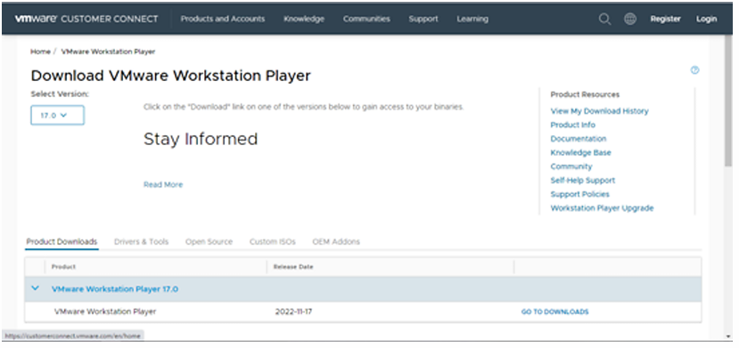](https://customerconnect.vmware.com/en/downloads/#)

Step 2: Now, Click on download now

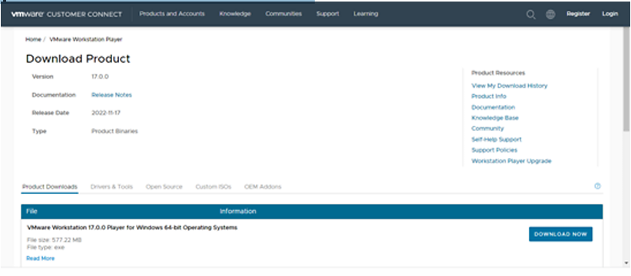

Step 3: Open the (.exe) file and install it. Step 4: Open the link below and download the Ubuntu ISO file. <https://ubuntu.com/download/desktop>

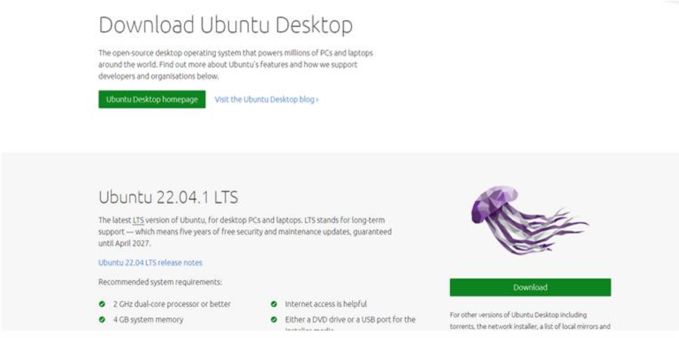

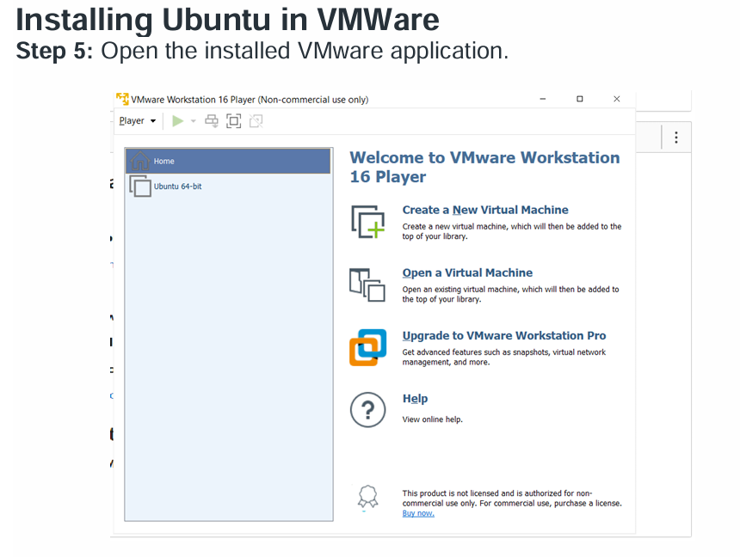

Step 6: Click on “Create new virtual machine”. Browse the ISO file that has been downloaded and select it.

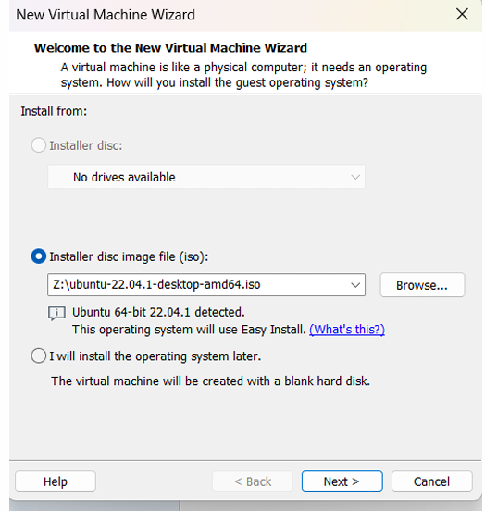

Step 7: Enter all the details >> click on next. Personalization of Virtual Machine.

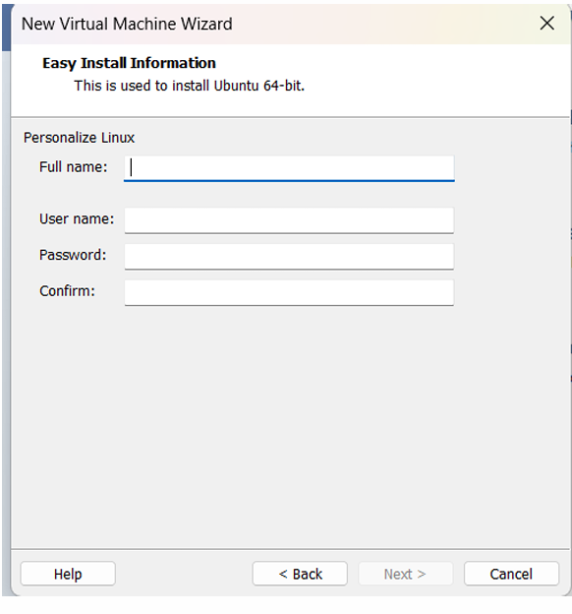

Step 8: Enter Virtual machine name >> click on next.

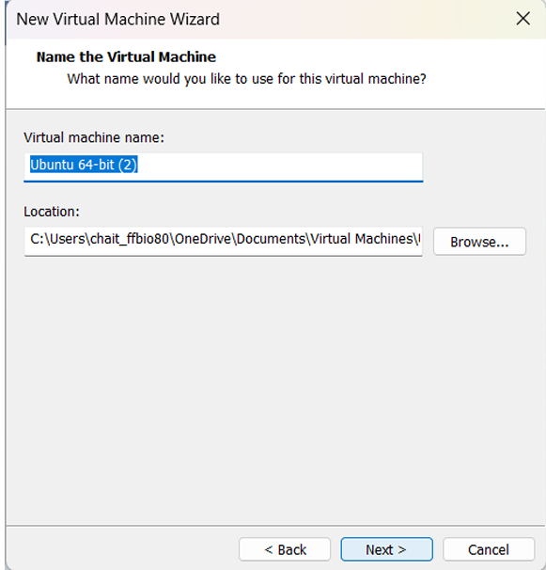

Step 9: Specify disk capacity >> click on next.

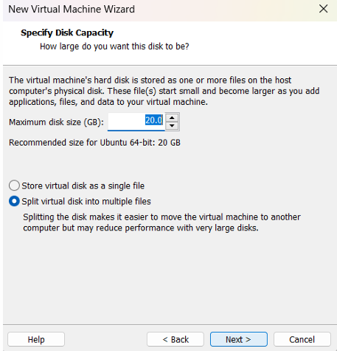

Step 10: If needed customize the hardware and click on finish

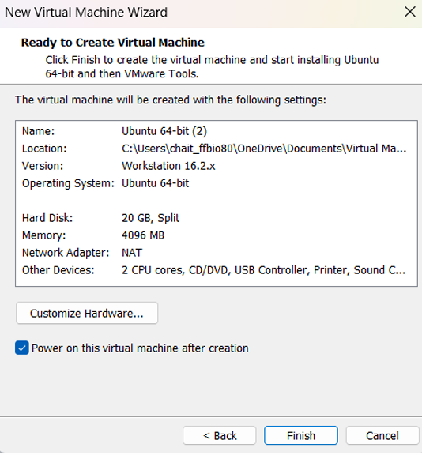

Step 11: Ubuntu has been successfully installed in VMWare. Now open VMware and click on ubuntu-64 which appears on the left panel. (If not directly opened). Select the language and click on next. Select the Normal or Minimal installation based on your requirements.

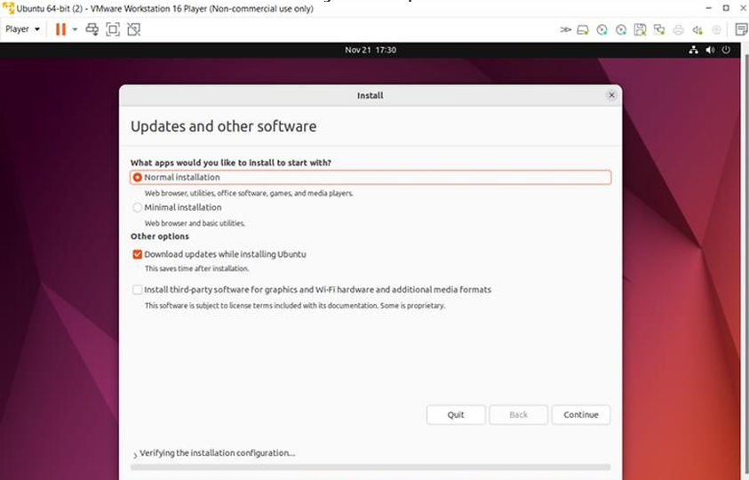

Step 12: Select Installation type >> Erase disk and install Ubuntu (This will not delete your windows data) >> Click on install now.

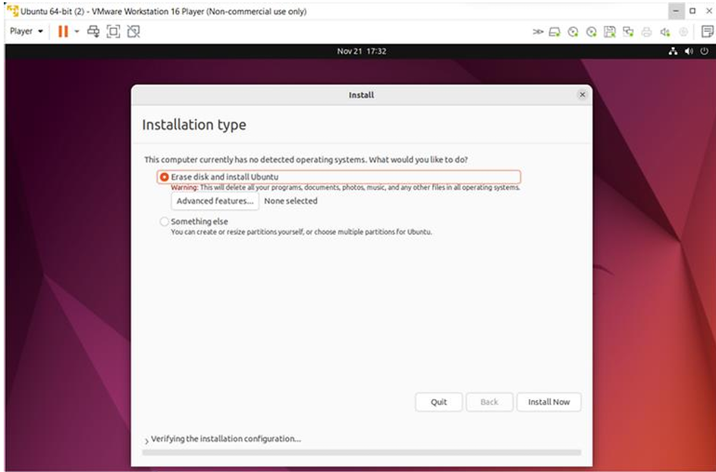

Installing Windows in VMWare Step 13 Similarly for windows just install windows 7 in place of Ubuntu (repeat steps from 5th step)